For Immediate Release
Wednesday, January 5, 2022

Contact:
Holly Jo Anderson
952-738-8177, ext. 700
holly@veritasmarketing.com

SONEX® Valueline Panels improve acoustics in classrooms at
Toronto’s Islington Junior Middle School

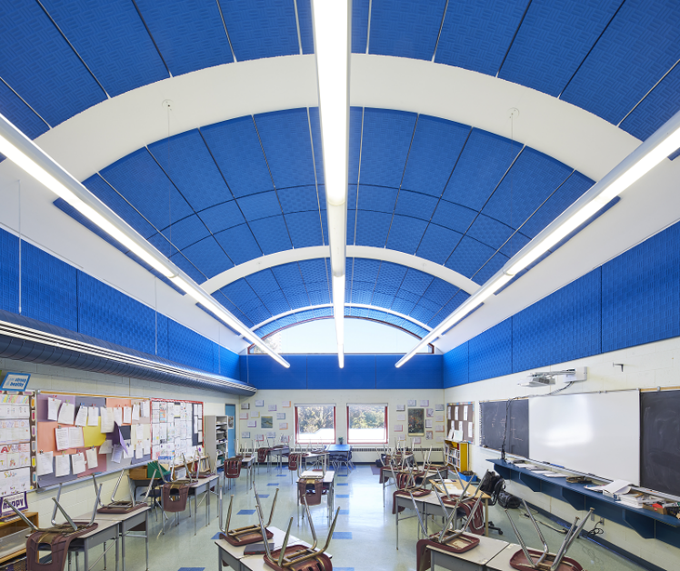
Established in 1832, Islington Junior Middle School is one of nearly 600 schools in the Toronto school district. Proud of its international cultural and linguistic diversity, Islington is attended by prekindergarten to eighth-grade students. To improve safety and the learning environment, SONEX® Valueline panels, from pinta acoustic, inc., were installed in four classrooms at Islington Junior Middle School.
The classrooms at Islington Junior Middle School had fabric-wrapped fiberglass panels installed on ceilings and walls; some of the panels became detached and dropped from the ceiling. Concerned about the weight of the panels and safety of students and faculty, school officials removed all the panels. The administration wanted to address the current issues and help establish quieter classrooms which have been known to improve academic performance while also reducing teachers’ stress. Typical classrooms have many hard surfaces that reflect sound rather than absorb it, thus reverberated sound tends to build up in a room making it quite difficult to hear and understand instruction. Administration officials at Islington Junior Middle School understand the importance of optimized classroom acoustics for student education and contacted Sound Solutions, Inc., located in Canada, for alternative acoustic product options.
Rakesh Rana, interior sales manager from Sound Solutions, Inc., recommended SONEX Valueline panels to replace the existing fiberglass panels. Lightweight, SONEX panels are flexible and can easily be installed on walls and curved ceilings with pinta’s acouSTIC™ adhesive.
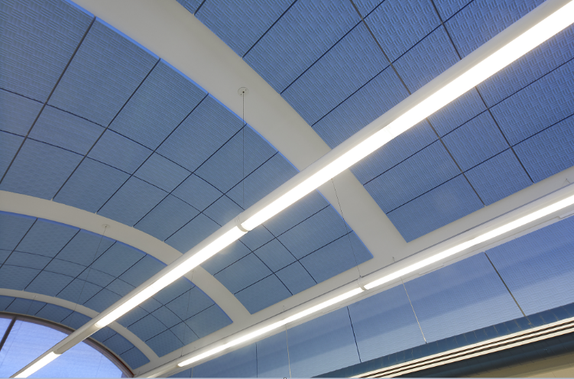
“We have been working with the Toronto District School Board for over 50 years,” says Rakesh Rana. “They wanted to mimic the original design in appearance. Offered in custom sizes and colors, SONEX Valueline panels were the best choice. Additionally, SONEX provides better sound absorption than the previous panels.”
Architects and school officials with the Toronto District School Board reviewed and approved the recommendation. A total of 5,664 square feet (526.20 square meters) of 1-7/8-inch (22 mm)-thick SONEX Valueline panels have been installed in Islington Junior Middle School. Each of the classrooms has 144 SONEX Valueline panels on the ceiling. The panels are 24 by 48 inches (610 by 1219 mm) and were easily installed with acouSTIC adhesive following the contour of the curved ceilings. Thirty additional 48- by 96-inch (1219 by 2438 mm) panels were glued to the walls of each of the classrooms, again using acouSTIC adhesive. The SONEX panels in two of the classrooms were coated with pinta’s premium water-based acoustic coating in frost-blue; panels in the other classrooms have a custom bright-blue water-based acoustic coating.
“The previous fabric-wrapped fiberglass panels had to be split on the back before installation to follow the contour of the ceilings. They were mechanically fastened to the walls and ceilings using clips attached to rails,” says Rana. “SONEX panels were much easier to install in this application. A team of people from the schoolboard installed the panels to walls and ceilings in all four classrooms.”
SONEX Valueline direct-apply, glue-up panels provide effective acoustical control at an economical price. Made from Class 1 fire-rated WILLTEC™ foam, lightweight SONEX expanded melamine foam products deliver excellent acoustic control across all sound frequencies with NRCs (noise reduction coefficients) ranging from 0.75 to 1.05. Offered in standard and custom sizes, SONEX products are available in a range of colors, including natural white, natural grey, standard, premium and custom acoustic color coatings. SONEX Valueline Panels are easy to install using pinta’s water-based acouSTIC adhesive on most porous substrate surfaces and can be cut easily to fit on site. Readily available in a variety of shapes, sizes and thicknesses SONEX products are low density, lightweight and flexible to meet a variety of applications.
For more information or to find a representative, visit www.pinta-acoustic.com or call 1.800.662.0032 or +1.612.355.4200. To download “The Science of Better Acoustics” white paper, go to http://bit.ly/acousticscience.
Sound Solutions, Inc.
Headquartered in Ontario, Canada Sound Solutions, Inc. is a leading distributor of innovative architectural products with over 50 years of experience. The company’s dedicated and knowledgeable team work closely with clients to assess their needs and develop solutions to ensure customer satisfaction. Sound Solutions strives to be the first choice for architects, designers and builders by providing superior interior and exterior architectural solutions. Soundsolutions.ca

pinta acoustic, inc.
pinta acoustic, inc. manufactures a broad range of attractive direct-apply, glue-up ceiling and wall panels, suspended lay-in grid panels, suspended baffles and clouds for residential, commercial and industrial applications. pinta acoustic’s product line includes WHISPERWAVE™, PHONSTOP™, CONTOUR®, HARMONI, WHITELINE®, SQUARELINE®, WILLTEC™ Flat Sheets, SONEX® Classic, SONEX Valueline, SONEX One, SONEX Mini, SONEX AFS, SONEX Linear Absorbers, SONEX Lumen Linear Absorbers, SONEX PLANO Absorbers, SONEX Rondo, SONEX Clean, PROSPEC® Barrier, Foam and Composite Materials, and acouSTIC™ adhesives.

Editor’s note: pinta acoustic, inc. prefers lowercase spelling of its entire name.

