FOR IMMEDIATE RELEASE

Tuesday, January 24, 2023

CONTACT:

Holly Jo Anderson
+1 952.738.8177
holly@veritasmarketing.com

Multi-Wing introduces the high-efficiency, high-pressure PMAX7™ fan
PMAX7 has fewer blades and narrow axial depth for compact spaces
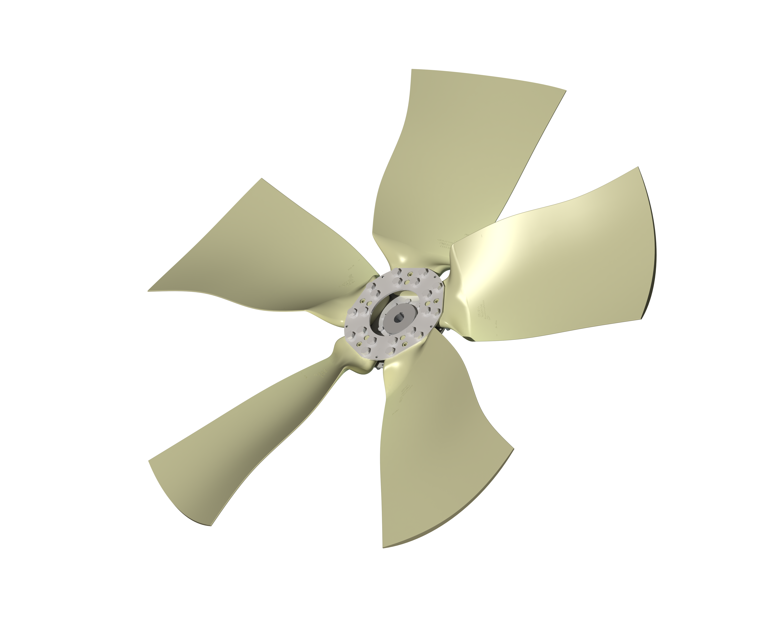

BURTON, Ohio—Multi-Wing introduces the high-pressure PMAX7™ axial fan, engineered to deliver increased airflow for power generators, harvesters and large construction equipment. Featuring fewer blades, PMAX7 has a lower profile to fit into tight spaces. Blades have an optimized backswept design for reduced noise and more efficiency in most applications.
Offered in diameters from 47 to 63 inches (1200 to 1600 mm), these modular fans are available with 5- and 7-blade configurations with 26°, 31° and 36° pitch angle options. Blades are constructed of polyamide, reinforced with glass fiber, which has an operating temperature from -76° to 221°F (-60° to 100°C). The hub is constructed of steel.
“PMAX7 meets market demand for shallow-profile, high-pressure fans that exceeds requirements in restricted spaces for specific large applications,” says Jody Coleman, research and development application engineer for Multi-Wing Group. “The flexibility of Multi-Wing’s broad line of modular-fan products, combined with dedicated engineering support, prototyping and advanced manufacturing, allows us to deliver the right fan, quickly.”
PMAX7 fans have tip speeds up to 351 feet per second (107 meters per second). PMAX7 fans of 63-inch (1600 mm) diameter are capable of operating at 1280 rpm. This high-static pressure fan is compatible with Cojali EV350 fan clutches.
To discuss your specific application with one of our engineering support specialists or to learn about PMAX7 fans, visit www.multi-wing.com/us/intro, call +1 440.834.9400 or email info@multi-wing.net. For access to our updated OPTIMISER fan selection application, visit www.multi-wing.com/us/optimiser.

Multi-Wing Group
Multi-Wing Group was established in the United States, Canada and Mexico in 1972 as Multi-Wing America. Headquartered in Middlefield, Ohio, Multi-Wing America is North America’s leading supplier of high-performance, modular axial fans in the broadest range of materials and blade profiles. Multi-Wing America is ISO 9001:2015 and 14001:2004 certified.

###

Multi-Wing America
+1 440.834.9400
info@multi-wing.net
www.multi-wing.com/us/intro

