FOR IMMEDIATE RELEASE CONTACT:
Monday, June 5, 2023 Holly Jo Anderson
+1 952.738.8177, ext. 700
holly@veritasmarketing.com

Diversified Plastics now offers ultra-precision micro-molding of highly engineered, intricate parts for medical devices and electronics manufacturing
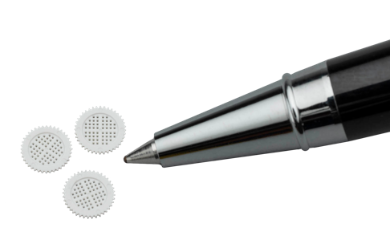
MINNEAPOLIS—Diversified Plastics, Inc. (DPI) delivers ultra-precision micro-injection molding and digital manufacturing of extremely small plastic parts for a range of markets, including medical device, electronics, industrial and others. DPI specializes in producing micro-molded parts that are often highly engineered with intricate geometries and features that are difficult and expensive to manufacture by other methods.
“DPI has extensive experience with tight tolerances and difficult-to-manufacture parts,” says Tom Venable, chief commercial officer at DPI. “We also have expertise in micro-molding materials and process validation to help customers get to market faster with the highest-quality parts.”
DPI’s technical representatives and experienced team of engineers work closely with customers, assisting them with design for manufacturing and other value-added services. ISO 13485 and 9001 certified, the company’s facilities include three Class 8 cleanrooms dedicated to molding and assembly for medical devices, including catheters, diagnostic systems, drug delivery devices, surgical instruments and other applications.
To learn more about DPI’s micro-injection molding and other manufacturing capabilities
or to request a quote, visit www.divplast.com/ultra-precision-micro-molded-plastic-parts/ or call
+1 763.424.2525.

DPI’s quality team and processes ensure that parts are consistently made to specification. A robust quality, inspection and measurement process is planned during the design for manufacturability phase. Verification of the dimensions for tools and finished parts are completed using high-magnification microscopic measurements.
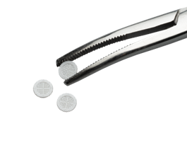
Common micro-molding materials include ABS, PEEK, PP, LCP, PET, PPS, PBT, POM, PEI, TPU, PPS, PPA, PSU, PC and PMP. DPI also offers value-added services, such as assembly and packaging to ensure that intricate parts arrive undamaged.
Micro-molding is a specialized manufacturing process that differs significantly from conventional injection molding. DPI creates parts with wall thicknesses as low as 0.007 inches (0.18 mm) and holes as small as .004 inches (0.10 mm), micro-part manufacturing can maintain dimensional tolerances of ± 0.0002 inches (±0.005 mm).

###
About Diversified Plastics, Inc.

Employee-owned Diversified Plastics, Inc. (DPI) is a contract manufacturer specializing in custom plastic-injection molding, micro-molding and additive manufacturing of high-precision, close-tolerance parts and components for medical device, industrial, electronics and a variety of other markets. Founded in 1977, the company is a full-service contract manufacturer providing design for manufacturing assistance, additive manufacturing, mold construction and intricate molding, as well as cleanroom assembly. The company has locations in Minneapolis, Minn. and Vista, Calif. DPI is ISO 13485 and 9001 certified, FDA registered, ITAR certified and UL registered. www.divplast.com
Diversified Plastics, Inc.
8617 Xylon Court North
Minneapolis, MN 55445
+1 763.424.2525
dpisales@divplast.com

