Integrated technology for recycling waste into renewable green energy and secondary resources

The world's population is expected to grow from 7 billion to almost 10 billion by 2050, leading to a significant increase in waste generation, especially in cities.
The application of integrated technologies of IFALLIANCEUSA LLC will achieve Goal # 1 “Ensuring open, safe, resilient and environmentally sustainable cities and human settlements” and Goal # 2 “Ensuring sustainable consumption and production patterns.”
Within those frameworks the IFALLIANCEUSA LLC company proposes the implementation of its technical achievements in solving the following tasks:
Task #1 - is to reduce the negative environmental impact of cities on a per capita basis, including by focusing on air quality and the management of urban and other waste.”
The Task #2 - is to achieve the sustainable management of chemicals and all wastes throughout their life cycle in accordance with agreed international principles and to significantly reduce their release into air, water and soil to minimize their negative impacts on human health and the environment.”

The Goal is to significantly reduce waste through prevention, reduction, recycling and reuse measures.”

Current waste processing technologies generally make it possible to remove the main types of waste, but do not completely (more than 90% of the mass) process the resulting waste into secondary resources. The created by IFALLIANCEUSA LLC integrated technology for processing waste into renewable green energy and secondary resources has shown such effectiveness.
The integrated technology for processing waste into renewable green energy and secondary resources is a line of main and auxiliary modules that allows you to completely process any type of waste into secondary resources and green energy (electricity, thermal energy).
Depending on the type of waste: municipal solid waste (MSW), waste from sewer networks and treatment facilities, hazardous waste, etc., various additional modules are added to the line, allowing no losses (excluding technological losses of about 1-1.5% throughout production chain) process any type of them. Basic modules are designed for mechanical preparation of raw materials, low-temperature thermolysis of raw materials with the release of thermolysis liquid, refining of thermolysis liquid and high-temperature thermolysis for processing residues from previous modules.

Basic received products of the complex:

The produced gases, regardless of the composition of the initial waste, undergo complete purification from all harmful compounds and can be used as thermal and electrical energy, gases for their own needs.
The produced liquids contain a large amount of hydrocarbon compounds, which will allow them to be used as raw materials for petrochemicals. The resulting by-products - water and aqueous solutions - are purified and can be used as industrial water for irrigation, industrial water for generating steam, industrial water for your own needs.
Solid residues - the resulting various types of carbon and carbon residues are secondary resources and are in demand in metallurgy and energy.

Depending on the morphology of the waste, various auxiliary modules are added to the complex to improve the resulting secondary products and increase their quality.

Integrated technology for thermal processing of waste into renewable green energy and secondary resources will significantly reduce the volume of waste through recycling and reuse, as well as reduce the negative impact on the environment by eliminating the release of hazardous substances into the air, water and soil.

Terms and definitions for the article
Integrated recycling of waste into renewable green energy using thermal destruction technology.
1. Module for mechanical preparation of solid waste for thermal destruction
2. Low-temperature thermalizes module for separating liquid fractions from solid waste
3. Module for refining liquid fractions and distillation to obtain commercially in demand products
4. High-temperature thermalizes module for the separation of high-calorie gas fraction and carbon black.

The IFALLIANCEUSA company
considers it its duty to convey the following prerogatives to both businesses involved in waste processing and the communities:

- Ensure cities and communities are inclusive, safe, resilient and environmentally sustainable
- Ensure sustainable consumption and production patterns.
All of us are already faced with tasks that must be solved today, otherwise tomorrow they will result in big problems if we don’t find rational solutions – and they can and should be voiced today – and all of us have to be involved in solving those problems

- halve per capita global food waste at the retail and consumer levels and reduce food losses along value chains, including post-harvest losses.”
- achieve the environmentally sound management of chemicals and all wastes throughout their life cycle in accordance with agreed international principles and significantly reduce their releases into air, water and soil to minimize their negative impacts on human health and the environment "
- significantly reduce the volume of waste by taking measures to prevent its generation, reduce it, recycle and reuse"

Definitions:
Hazardous waste is solid waste with chemical composition or other properties that make it capable of causing illness, death, or other harm to people, plants, animals, and ecosystems if improperly managed or released into the environment.

Waste disposal status: At what point in the recovery process does the waste cease to be a waste and re-qualify as a resource?
Environmentally sound treatment of hazardous waste – waste treated in accordance with technical guidelines adopted by the Conference of the Parties to the Basel Convention or in accordance with national standards.

• Treatment of hazardous waste – “disposal” (D1-D15) and “recovery” (R1-R13) operations specified in Annex IV of the Basel Convention.
• Recycling is any processing of waste that removes it from the waste stream, other than reuse as fuel. This also includes recycling. Recycling of waste at industrial enterprises, that is, at the place of production, should be excluded.
• Incineration - controlled combustion of waste, with or without subsequent energy recovery.
• Waste disposal is the final disposal of waste in or on land in a controlled or uncontrolled manner.
• Controlled waste disposal site is a waste disposal site that is permitted and operated in accordance with applicable national or international legal requirements.

Municipal solid waste (MSW) is waste arising from the activities of households, trade and turnover, small businesses, office buildings and institutions.
MSW also includes bulk waste and waste from individual municipal services, but excludes waste from municipal sewer networks and wastewater treatment plants, municipal construction waste and demolition debris.

Our technology.

1. Category of the object of negative impact on the environment?
– All objects proposed to organizations belong to the III category of negative impact on the environment.
2.Sanitary hazard class of an industrial enterprise?
– All objects proposed by organizations have a 2nd class of sanitary hazard.
3.Size of the required sanitary protection zone (in meters)?
– The required sanitary protection zone for all attached objects = 500 meters.
4. Availability of an EIA for the proposed projects (similar to projects implemented in other regions)?
– The EIA for the proposed objects will be carried out in accordance with the legislation during the formation of OBIN and agreed upon in the prescribed manner. (we have experience in developing and approving similar objects).
5.Are there state environmental assessments for similar projects?
- Mr. the examination of the proposed objects will be carried out in accordance with the legislation during the development of the project and agreed upon in the prescribed manner. (there is experience in approving similar objects).
6.License for waste disposal of the corresponding hazard class?
– Necessary licenses for activities will be obtained in accordance with the law.
7.Are there harmful emissions into the atmosphere during the production process, and do they comply with maximum permissible concentrations?
– There are no harmful emissions into the atmosphere in excess of the standard during the production process. Documentation on emissions and calculations will be submitted to the control authorities after the development of the OBIN project. Laboratory assessment of harmful emissions into the atmosphere will be carried out by an accredited laboratory after the facilities are put into operation.
8. Do you have an environmental passport for production?
– Sanitary and environmental passports for production facilities will be completed after concluding contracts for the implementation of projects and conducting marketing research in order to accurately determine the volume of solid waste processing.
9.Annual volumes of waste processed and product output?
Answer:
9.1.1.Annual volume of recycled rubber waste tires (per module);
Waste car tires = 30,000 tons.
Spent pneumatic chambers and rubber goods = 2,000 tons.
9.1.2. Annual production volume;
Steel cord grade (AISI)-1070.1074.1086. spring steel (alloyed)
= 2,800 t/year.
Carbon technical N-660 - in accordance with classification according to ASTM D1765 standard. = 8,500 t/year.
Electric energy at feed-in tariff = 51,600 MW/year.
Thermal energy = 62,000 Gcal/year.
Production of aromatic fuel compounds fraction = 14,000 tons/year.
9.2.1.Annual volume of municipal solid waste;
Reception and processing of municipal solid waste = 120,000 tons/year.
9.2.2. Annual production volume;
Carbon technical N-805. = 34,130 t/year.
Electric energy at feed-in tariff = 62,600 MW/year.
Thermal energy = 56,600 Gcal/year.
Fraction of aromatic fuel compounds = 42830 t/year.
9.3.1.Annual volume of processing and refining of thermolysis liquid;
Reception of fractions of aromatic and fuel compounds. = 60,630 t/year.
9.3.1.Annual volume of products;
Product name and volume (tons/year);
Technical tar = 9,100 t/year.
The distillate fraction of aromatic compounds starts boiling at up to 1800C. = 34,280 t/year.
The distillate fraction of solvent compounds starts boiling at 1800C - 3600C. = 17,250 t/year.
9.4.1.Annual volume of processing of dehydrated sewage waste, poultry and pig manure waste:
Reception of dehydrated sewage waste, poultry and pig litter waste = 32,000 tons.
9.4.2.Annual volume of products;
Carbon technical for the preparation of asphalt mixtures. – 16,000 t/year.
Electric energy at feed-in tariff = 20,800 MW/year.
Thermal energy = 21,600 Gcal/year.
Fraction of aromatic fuel compounds = 3,800 t/year.
10.Does the project provide equipped storage areas for raw materials on the site?
– Provided in accordance with fire regulations.
11. Approximate timeframe for project implementation? When is it planned to commission and reach design capacity?
– December 2025
12. In collaboration with companies, analyzes of incoming waste and outgoing commercial products were carried out.

Produced Synthesis Gas.
Gas chromatographic analysis of synthesis gas obtained from the thermal destruction of wastewater sludge (WWW) in the temperature range (610°C-620°C) showed the presence of the following components in the gas mixture:
Table No. 1. Contents of components in the gas sample.
There is no hydrogen sulfide.
oxygen present: in the sample - approximately 1%

components | %, volume
 | H2 | N2 | CH4 | CO | CO2 | ethane ethylene | propane propylene | С4 | С5 | С6 | Н2О | total
610°С-620°С | 21,80 | 10,66 | 26,00 | 16,71 | 7,40 | 8,36 | 3,39 | 2,66 | 2,07 | 0,99 | 1,63 | 100,0

The calorific value of synthesis gas obtained by thermal destruction of wood waste is:
A sample of synthesis gas was obtained at a heating temperature = 610°C-620°C
Heat of combustion of synthesis gas:
G lowest = 16.6 MJ/m3.
The density of synthesis gas, , at a heating temperature of 610°C-620°C is:
P =1.025 kg/m3.

Table No. 2. Detailed composition of the organic part

.
№ | component
 | Synthesis gas sample 610°С-620°С
1 | metan | 64,65
2 | ethan | 2,38
3 | ethylen | 30,85
4 | propan | 0,03
5 | propylene | 1,06
6 | ацетилен | 0,29
7 | изобутан | 0,03
8 | н-бутан | 0,003
9 | сумма С4 (бутилены) | 0,10
10 | дивинил | 0,34
11 | н-пентан | 0,07
12 | сумма С5 (пентены) | --
13 | сумма С6 и выше | 0,20

The producing of carbon from tires.
Product Name: Carbon Black
Determination of fractional and elemental composition

N | parameters | Ед. изм. | Циклон 1 | Циклон 2 | methodology ASTM
1 | Iodine adsorption number (Iodine number) | Gr/kg | 12,1 | 8,9 | D1510
2 | Specific surface area for nitrogen adsorption, BET method | м²/gr | 34 | 29
3 | meaning pH | б/р | 7,8 | 7,07 | D1512
4 | Heating losses, no more | % | 1,6 | 1,6 | D1509
5 | Mass fraction of ash, no more | % | 17,2 | 39,1 | D1506
6 | Bulk density, not less | кг/м³ | 254 | 570 | D1513
7 | Elemental composition
 | Zn | % масс | 3,0800 | 2,44
 | Si | % масс | 2,3500 | 2,54
 | S | % масс | 1,1900 | 1,16
 | Ca | % масс | 0,5530 | 0,802
 | Al | % масс | 0,2600 | 0,329
 | Fe | % масс | 0,2040 | 0,447
 | Mg | % масс | 0,1270 | 0,179
 | Na | % масс |  | 0,1530
 | K | % масс | 0,0844 | 0,1020
 | Cl | % масс | 0,0598 | 0,0653
 | Br | % масс | 0,0542 | 0,0336
 | P | % масс | 0,0518 | 0,485
 | Ti | % масс | 0,0211 | 0,0268
 | Co | % масс | 0,0185 | 0,0153
 | Cu | % масс | 0,0157 | 0,0118
 | Cr | % масс | 0,0057 | 0,0084
 | Ba | % масс |  | 0,0061
 | W | % масс | 0,0056 | 0,0026
 | Ni | % масс | 0,0046 | 0,0043
 | Hf | % масс | 0,0037 | 0,0023
 | Mn | % масс | 0,0030 | 0,0082
 | I | % масс | 0,0028
 | Sr | % масс | 0,0018 | 0,0028
 | Pb | % масс | 0,0018 | 0,0018
 | Ag | % масс | 0,0015
 | Re | % масс |  | 0,0014
 | Nd | % масс |  | 0,0012
 | Carbon | % масс | 91,9000 | 91,5600
 | ----- | % масс | 0,0000 | 0,0153
 | total | % масс | 100,0000 | 100,0000

The resulting products from the refining of thermolysis liquid, from the processing of mixed, unsorted solid waste.
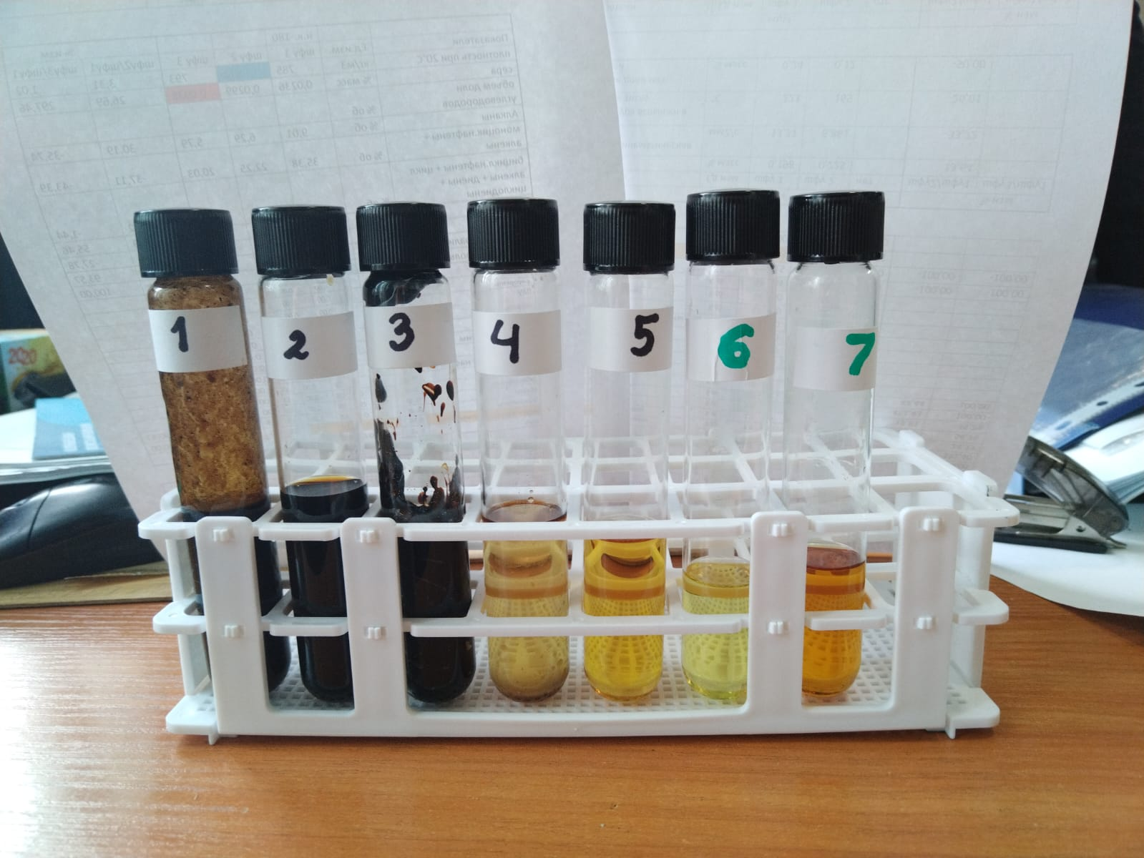

Test tube No. 1 - Initial thermalizes liquid.
Fractions obtained after receipt processing and fractionation (CHF 2)
Test tube No. 2 - Fraction beginning of boiling – 3600С
Test tube No. 3 - The fraction begins to boil over 3600C. (trade product Gudron).
Test tube No. 4 - Water (aqueous solution) obtained during fractionation.
Fractions obtained after receipt + catalytic processing and fractionation (CHF 3)
Test tube No. 5 - Wide fraction, beginning of boiling – 3600C.
Distillates obtained from the wide fraction (commercial products)
Test tube No. 6 - Fraction beginning of boiling – 1800C. (a set of aromatic compounds and solvents).
Test tube No. 7 - Fraction beginning of boiling - 1800C - 3600C. (fuel fraction).

