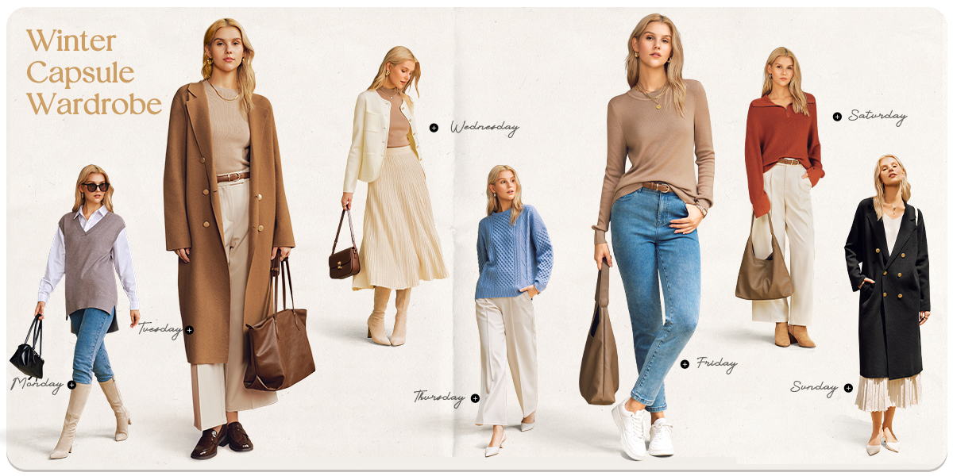
Arach&Cloz 5th Anniversary Campaign: High Five To Cozy
Arach&Cloz started its journey with the belief that true elegance should never come at the expense of ease. From the very beginning, the brand has stayed aligned with “Naturally you, Naturally cozy,” blending natural fibers with modern craftsmanship to tame their inherent delicacy. Each piece is made to bring both comfort and charm, empowering urban women to remain composed and confident no matter how busy life gets.
Among Arach&Cloz’s signature pieces, sweater pullovers and shrugs have long been customer favorites, earning top rankings on Amazon. This trust is rooted in the brand’s unwavering commitment to quality and design. From selecting skin-friendly fabrics, enforcing strict quality control, and upholding sustainability, to shaping diverse silhouettes and crafting thoughtful details, all come together to offer easy sophistication from morning to night. It is this balance of function and aesthetics that has made Arach&Cloz a reliable companion in the urban wardrobes.
This year, Arach&Cloz celebrates its 5th anniversary with the “High Five To Cozy” campaign, honoring a dedication to cozy living. Here, “cozy” is redefined across five senses: soft touch, pleasing visuals, versatile styling, emotional resonance, and enduring wear. Every outfit is designed to feel effortless yet expressive, bringing warmth and confidence into every moment of modern life.

To mark this milestone, Arach&Cloz has introduced a Winter Capsule Wardrobe featuring 11 essential pieces. Capturing the common concerns of work wardrobe, such as bulky fits, poor shape retention, and high maintenance, the product team has carefully selected premium wool or cotton blends to ensure both lightweight warmth and easy care. Defined by clean lines and polished tailoring, the collection is smartly crafted for everyday wear, delivering a neat and sharp silhouette for office attire while highlighting the refined style of modern women. Whether from daily commutes and business events to casual socials and chic outings, these pieces serve as elegant staples. As one customer shared: “If you're into timeless, understated fashion or need something office-appropriate, this is a great option.”
For five years, Arach&Cloz has been made to last and designed for comfort, never chasing fleeting trends but embracing every facet of real life.
The 5th Anniversary Campaign will coincide with Black Friday, running from November 20 to December 1. Alongside the 11 winter capsule essentials, popular fall and winter pieces will also be on sale, offering exclusive promotions and styling inspiration. Stay tuned for more from Arach&Cloz’s official social media and join it in saying: High Five To Cozy!



