FOR IMMEDIATE RELEASE

Contact:
Holly Jo Anderson
Veritas Marketing, holly@veritasmarketing.com, +1 952-994-4455

Chromatic 3D Materials Demonstrates Breakthrough in 3D Printed Rocket Propellant to Strengthen Defense Readiness

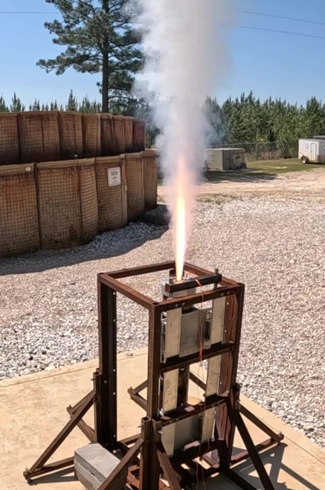
Minneapolis, MN, April 28, 2026 — Chromatic 3D Materials today announced successful prototype printing and static fire testing of its additively manufactured rocket propellant at the Integrated Solutions for Systems (IS4S) test range in Opelika, Alabama. The tests demonstrated that Chromatic’s printed propellant can sustain combustion pressures beyond 1800 psi without structural failure, marking a critical milestone in advancing resilient, next-generation propulsion manufacturing for rockets and defense applications.

Chromatic’s propellant achieves energetic loading levels comparable to top-performing conventional propellants while delivering the structural integrity required to withstand high-pressure combustion environments. Together, these attributes enable propulsion performance on par with today’s fielded systems, with a clear pathway to surpass them. Based on current results, Chromatic’s material has the capability to propel approximately 90% of the U.S. rocket arsenal with equivalent speed and range—while creating opportunities to further enhance both.

Beyond matching conventional systems, Chromatic is leveraging its multi-material 3D printing capabilities to unlock new performance regimes. The company’s ability to print propellant directly onto or within structural components enables optimized geometries, improved mass efficiency, and unique thrust control—advancements that can translate directly into increased thrust, extended range, and greater mission flexibility.

Founded in 2016, Chromatic 3D Materials developed RX-AM™ (Reactive Extrusion Additive Manufacturing), a proprietary platform for 3D printing durable elastomeric materials. Over the past two years, the company has extended RX-AM to rocket propellant by adapting conventional polybutadiene propellant binder chemistries for its additive manufacturing process. This approach enables a safer, lower-cost, and significantly faster production process while maintaining—and increasingly exceeding—the performance standards required for operational systems.

At a time when defense supply chains face increasing strain, Chromatic’s manufacturing model offers a path to greater agility and resilience. By enabling on-demand, distributed production of rocket propellant, RX-AM reduces dependence on complex, centralized infrastructure while simultaneously delivering next-generation performance improvements.

“These results demonstrate that additive manufacturing is not only viable for defense propulsion—it can drive meaningful performance gains across at least 90% of the U.S. rocket arsenal,” said Dr. Cora Leibig, Founder and CEO at Chromatic 3D Materials. “We’re showing that it’s possible to maintain compatibility with existing systems while opening the door to rockets that fly farther, hit harder, and can be produced faster.”

Chromatic 3D Materials continues to partner with government and industry stakeholders to accelerate adoption of additive manufacturing technologies that enhance readiness and supply chain resilience.

For more information, visit c3dmaterials.com email info@c3dm.com to learn more.

# # #

