FOR IMMEDIATE RELEASE

Minnesota-Based Chromatic 3D Materials Establishes Advanced Rocket Propellant Test Capability at Camp Ripley

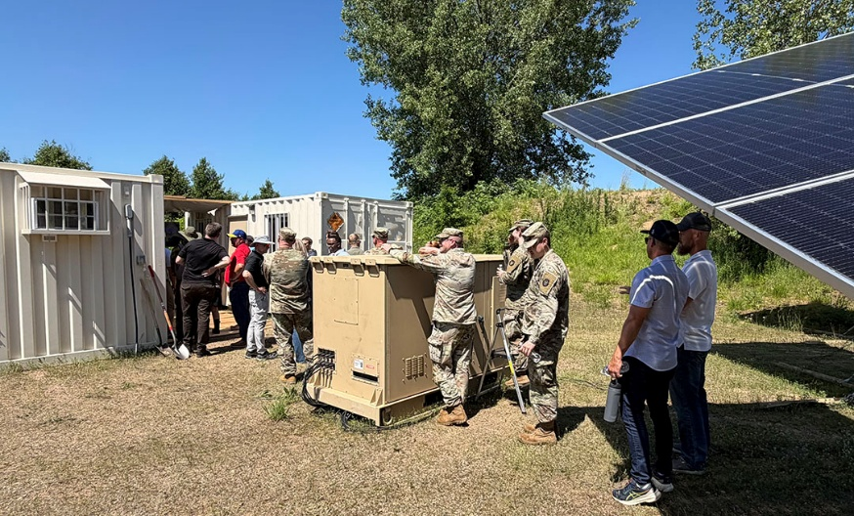
Minneapolis, Minn.—Chromatic 3D Materials announced the establishment of an integrated rocket propellant test-firing capability at Camp Ripley, a 53,000-acre National Guard training facility near Little Falls, Minn. Effective June 1, Chromatic entered into a five-year lease agreement to establish a long-term testing presence at Camp Ripley. This expansion strengthens Chromatic’s ability to rapidly develop, validate, and scale next-generation propellant technologies in support of national defense priorities.

The opportunity was made possible through collaboration with Defense Innovation OnRamp Hub: Minnesota and the Minnesota National Security Ecosystem, which connected Chromatic with Camp Ripley and the Minnesota National Guard. Together, they created a pathway for the company to establish a sustained testing presence and validate its technology in an operationally relevant environment. OnRamp Hub: Minnesota is part of the Department of War’s initiative to accelerate the adoption of dual-use technologies that address national security needs.

The partnership also brought together LEMA, a Minnesota-based expeditionary power company under contract with the U.S. Army Corps of Engineers, to explore the integration of resilient power generation with Chromatic’s advanced manufacturing and propulsion testing.

“Commercial companies often have promising technologies but need access to the right partners, facilities, and testing environments to demonstrate their capabilities and move forward,” said Matt Hickey, managing director of OnRamp Hub: Minnesota. “Our role is to help make those connections, reduce barriers to testing and evaluation, and create pathways that accelerate getting commercial technologies into the hands of the warfighter. The collaboration between OnRamp Hub: Minnesota, Chromatic, LEMA, Camp Ripley, and the Minnesota National Guard is a strong example of what that can look like in practice.”

By co-locating a dedicated propellant print lab with an on-site test firing infrastructure, Chromatic has created a closed-loop development environment that enables a direct transition from fabrication to live-fire evaluation. This capability significantly accelerates iteration cycles, allowing for the rapid refinement of propellant performance under operationally relevant conditions.

“Development and manufacturing speed are critical in modern defense,” said Cora Leibig, CEO of Chromatic 3D Materials. “Our presence at Camp Ripley allows us to rapidly demonstrate performance, validate manufacturing approaches and reduce the time required to deliver advanced propulsion solutions to rocket manufacturers.”

Camp Ripley provides a secure, controlled testing environment aligned with Department of War standards, enabling Chromatic to conduct propulsion demonstrations while maintaining close integration with Minnesota-based operations. The on-site print lab further enhances responsiveness, supporting rapid prototyping and immediate validation of new formulations and grain geometries.

In parallel with Chromatic’s propulsion testing activities, Chromatic and LEMA are collaborating to demonstrate forward-deployed solar power generation capabilities at Camp Ripley. This effort explores how distributed, resilient energy systems can support expeditionary manufacturing and testing operations in austere environments. By integrating portable solar generation with on-site propellant production and testing, Chromatic and LEMA aim to showcase a model for an energy-independent, rapidly deployable defense infrastructure. This combined capability highlights the potential for operating advanced manufacturing and propulsion testing in forward or resource-constrained settings, reducing logistical burdens while increasing operational flexibility for U.S. forces.

This development represents a key milestone in Chromatic’s path toward full-scale rocket propellant manufacturing. By proving repeatability and performance through accelerated test cycles, Chromatic is advancing the readiness of its technology for deployment across defense applications, including tactical and strategic propulsion systems.

Chromatic’s investment at Camp Ripley reinforces its commitment to strengthening the U.S. defense industrial base through innovative, scalable manufacturing solutions that enhance speed, flexibility, and mission readiness.

For more information, visit c3dmaterials.com or email info@c3dm.com.
# # #
Contact:
Holly Jo Anderson
Veritas Marketing, holly@veritasmarketing.com, +1 952-994-4455

