For Immediate Release
Monday, October12, 2026

Contact:
Holly Jo Anderson
Veritas Marketing
952-994-4455, holly@veritasmarketing.com

Array Technologies Introduces RealSync™ Smart Packaging Production Platform at PACK EXPO International 2026
Reduce label reliance with direct-to-package printing, integrated data and verification

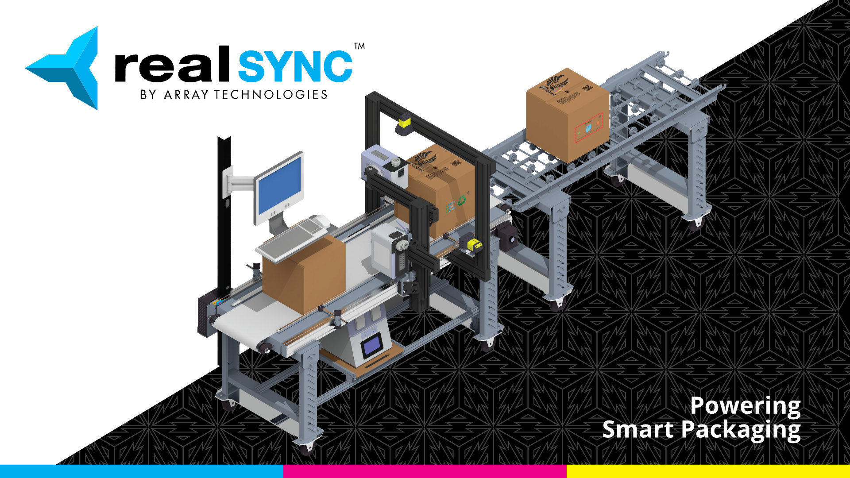
GLASTONBURY, Conn.—Array Technologies will introduce RealSync™, an integrated smart packaging production platform designed to simplify how manufacturers and packaging producers manage, print, verify and deliver unique package-level data, at PACK EXPO International 2026, Booth W-39050.

RealSync enables manufacturers to print variable information directly onto packaging during production, providing an alternative to preprinted labels for a wide range of applications. By moving variable content into the production workflow, manufacturers can reduce label and packaging inventories, minimize waste and simplify the management of changing SKUs and product information. Learn more at arrayonline.com/product/real-stamp/.

As demand for greater product identification, traceability and packaging intelligence grows, manufacturers are managing increasingly complex data requirements. RealSync brings data management, industrial mono- or color-inkjet printing, machine vision verification and smart packaging technologies together within one scalable production platform.

RealSync manages variable data, prints unique information directly onto packaging at production speed, verifies that the correct information is associated with each package and delivers package-level data for reporting, traceability and downstream use. The platform can operate with an on-premises server, giving manufacturers local control of production data without requiring cloud connectivity.

“RealSync is about making smart packaging practical on the production floor,” said David Pirie, President
of Array Technologies. “Rather than treating printing, data encoding, verification and connected packaging as separate processes, we’ve brought them together into one workflow that can be configured around the manufacturer’s application.”

RealSync supports a range of variable and connected packaging technologies, including barcodes, QR codes, SKUs, GTINs, lot numbers, production dates to RFID, Bluetooth Low Energy tag cloud-based asset tracking via Wiliot, Amazon Transparency codes, GS1 Digital Link and other unique identifiers. Machine vision and RFID verification help confirm that the correct data are associated with each package and create production records for downstream reporting and traceability.

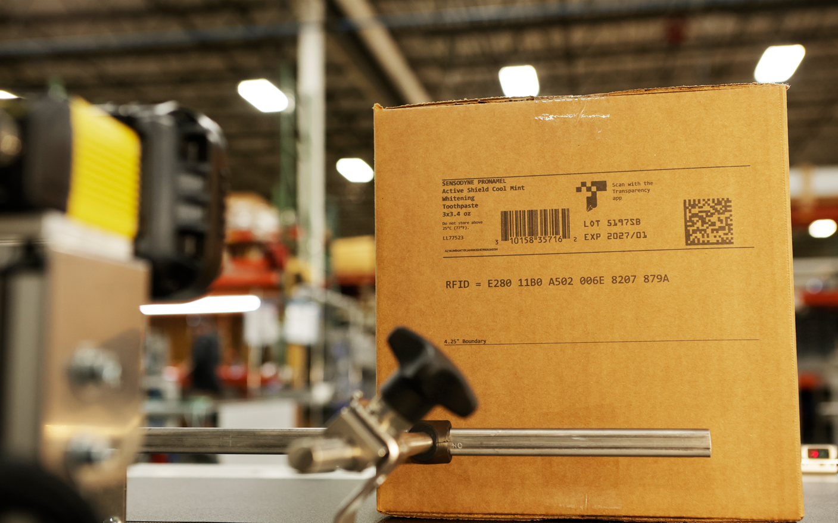
The platform can be configured for an individual production machine or scaled across larger operations, allowing manufacturers to start with current requirements and expand as these requirements evolve.

RealSync supports applications across packaging, food and beverage, pharmaceutical and other manufacturing environments in which accurate product data and package-level traceability are increasingly a requirement. The platform can help manufacturers prepare for evolving identification and data-sharing requirements, including GS1 Sunrise 2027 and the FDA Food Traceability Rule, while supporting workflows that use GS1 standards, such as GS1 Digital Link.

By connecting production data with the information printed, encoded and verified on each package, RealSync provides a bridge between production-floor operations and broader product-data and traceability systems. Package-level data can be delivered to local, cloud or enterprise systems for downstream use.

At PACK EXPO International, Array Technologies will demonstrate the RealSync workflow and its ability to integrate data, printing and verification in a production environment. Manufacturers can submit their own production data before the show, and Array will prepare a demonstration using their application.

Attendees can visit Array Technologies at Booth W-39050. Free PACK EXPO registration is available using code 77F80.

About Array Technologies

Array Technologies develops and manufactures integrated printing, vision, data management and workflow solutions for the print, mail, packaging and bindery markets. Headquartered in Glastonbury, Connecticut, the company brings research and development, supply chain and manufacturing together under one roof to deliver reliable, production-ready systems for customers around the world.

Array’s capabilities include industrial inkjet printing, variable data solutions, machine vision inspection and fully integrated software workflows. These technologies help manufacturers improve production accuracy, verify printed and encoded information, manage variable data and increase productivity across demanding production environments.

